

Instituto Tecnológico y de Estudios Superiores

de Monterrey

**Biomechatronic Laboratory**

Februar-June 2021

Professor:

[Dr. Joel C. Huegel W.](https://experiencia21.tec.mx/courses/65615/users/74522)

Dra. Ramona B. Alemón Galindo

Ing. Marco Antonio González Barreto

**Instrumentation of a pressure sensor array**

**Roberto Estrella Mariscal A01632954**

Index

2 Introduction 2

3 State of Art 3

4 Problem statement 3

5 Solution Proposal 3

6 General Objective 3

7 Device Definition 4

8 Particular Objectives 4

9 Technical Documentation 4

9.1 Sensor Tekscan A201 4

9.1.1 Calibration 8

9.2 PIC Microcontroller 8

9.2.1 IDE Mplab 8

9.2.2 Code Organization 8

9.2.3 PIC peripherals 9

9.2.4 Upload of Code with PICK-IT 9

9.3 User Interface Computer 9

9.3.1 Plotter 9

9.3.2 User Interface Structure 9

9.4 Schematic 9

9.4.1 Configuration of the Sensor 9

9.4.2 Complete Schematic 9

9.5 Proposed improvements 9

# Introduction

(presenta de manera general los aspectos más importantes del proyecto).

When using a prosthesis there could be residual limb pain. There could be many reasons for the pain, but it could be mainly the fit or the design of the prosthesis. A way to analyze the performance of prosthesis is measuring the pressure between the stump and the prosthetic limb on specific points of interest. To accomplish this, a sensor measurement system is required.

In this project a functional prototype for a pressure measuring system will be developed to determine the pressure distribution on a lower body limb on determined points of interest.

# State of Art

In other research projects the objective to measure the difference in the performance of different prothesis was proposed. In the research from Pitkin (2009) the mobility and the comfort from different prothesis was measured with angles of movement the feedback from the user. As well as the last measurements pressure measurement were taken with the F-socket from Tekscan. It was concluded that the mobility and comfort what directly related with the peak pressure values.

Additionally, from this project in the Biomechatronic Lab there was a first prototype developed by Salvador Ibarra (2020). A first functional system was achieved and a comparison between the F-socket and this new pressure system was done. The F-socket measures the whole surface of the stump with a big array of sensors, in comparison with the system developed by Ibarra where it only measured with few sensors in specific points of interest. The conclusion is that the measurements and the data collected by both systems have the same quality. The F-socket can haver broader information but the system developed by Ibarra has more accuracy.

# Problem statement

Although the last prototype of pressure measuring system works, it needs improvements. To star with the system is in a prototype stage, and it had areas that could be improved to achieve a final product stage. The measurements were not reliable nor repeatable. The reproduction of the system was also problematic due to the lack of documentation. Two technical improvements for the project were required, the capacity to read up to 8 sensors and an increase in the resolution of the samples.

# Solution Proposal

The proposal to improve the system are to implement a PIC microcontroller which has more analog channels. Another aspect is to improve the schematic used with the ADC to improve it´s resolution. This schematic is related with the configuration of the sensor.

# General Objective

Design and code a device that measures in real time the pressure of a transfemoral leg stump, working with up to 8 Flexi sensors. Migrate from Arduino microcontroller to PIC16F886.

# Device Definition

To define the technical requirements from the system the context of use of the device is analyzed. The sensor system would be used in tests where the sensors are placed on the stump of the subject and then will be invited to walk on a treadmill. The subject of the test should have freedom of movement, so a wireless communication will be preferred. For an operator would be practical to have access to the information fast and easily, make an initial hypothesis based on the data provided by the system, to verify that the test is correct and make any correction on the sensor’s installation if needed. Due to the natural tendency of the sensors to de-calibrate, the system should have a way to test the calibration of the system and possibility to calibrate it.

# Particular Objectives

The particular objectives are that the device fulfills with the following technical requirements:

* Capacity for 8 sensors
* Sample rate: 20 ms
* Usage of 80% ADC capacity
* Wireless communication
* Real time graphics with same rate
* Save of samples for future analysis
* Capability to calibrate each sensor with computer interface
* Surface Mount Device (SMD) componentes on PCB
* Sensor connectors that withstand movement induced by gait

# Technical Documentation

## Sensor Tekscan A201

This pressure sensor works like a variable resistor, in which the resistances changes depending on the force. When the sensor has no pressure, it has its highest resistance, and as pressure increases resistance decreases. The change in resistance is not linear, but the conductance is, to take benefit of this characteristic opamp configurations are implemented to have a linear output.

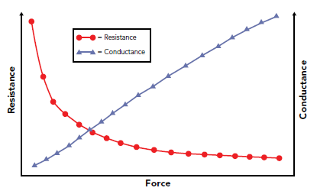

Figure 1. Resistance and conductance curve

The sensor has a ±40% sensor-to-sensor variation according to the datasheet (Tekscan,2020). Due to this each sensor must be calibrated individually. The Sensing area has a dimension of 9.53 mm (0.375 in.) diameter. The sensor can measure up to 4,448 N (1,000 lb). The sensor has 3 pins but just the two on the borders work.

There are two configurations for the sensor with an inverting amplifier and with a non-inverting amplifier. The inverting amplifier has no offset, but the noninverting amplifier has an offset that is the voltage reference. This behavior is represented by the following formulas, which are the formulas of the output in these opamp configuration. When the sensor has no pressure it’s resistance is very big in comparison with the feedback resistance so it tends to infinity. When the sensor has pressure its resistance is very small in comparison with the feedback resistance, that is why it tends to 0.

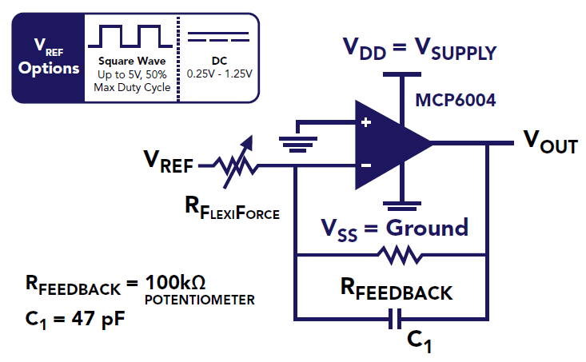

Figure 2. Inverting configuration dual source excitation circuit

|  |  |
| --- | --- |
| $$V_{o}=-V_{ref}*(\frac{R_{feedback}}{R_{flexiforce}})$$ | ( 1) |

|  |  |
| --- | --- |
|  | ( 2) |

|  |  |
| --- | --- |
|  | ( 2) |

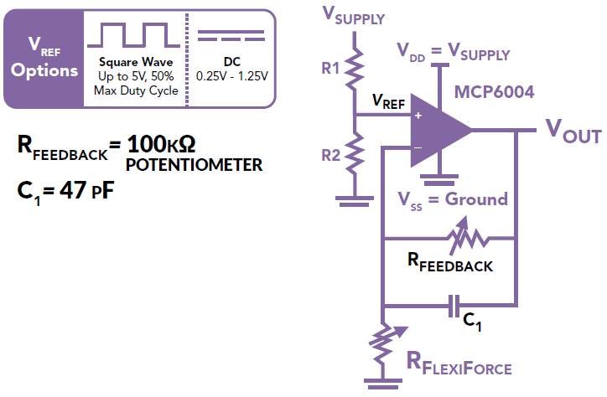

Figure 3. Noninverting configuration individual source excitation circuit

|  |  |
| --- | --- |
| $$V_{o}=V_{ref}*(\frac{R_{feedback}}{R_{flexiforce}}+1)$$ | ( 3) |

|  |  |
| --- | --- |
|  | ( 4) |

|  |  |
| --- | --- |
|  | ( 5) |

As shown in the analysis the inverting configuration goes from 0 up to the Voltage supply that is the saturation of the opamp. With the non-inverting configuration, the range of the output is from the Voltage reference to the saturation of the opamp. The inverting configuration gives a broader range of values, but the need of two voltage sources complicates the design, that is why the non-inverting configuration is applied.

Also, from the recommendation of the configuration a voltage reference between .25-1.25 must be applied. That’s why a voltage reference of 300 mv is proposed to have a broader range of values in the output.

According to the manual and like in the Figure 2 and Figure 3 the recommended Opamp is the MCP6004 because it has rail to rail property, what it means is that the maximum output of the Opamp is very near from the power supply voltage.

### Calibration

## PIC Microcontroller

The most important aspect of the microcontroller is its capability to measure up to 8 sensors. For this reason, the PIC16F886 microcontroller is selected, being that has 10 ADC channels, UART and has no additional peripheral which could increase the price and which are not going to be used.

### IDE Mplab

The Integrated Development environment used to program PIC microcontrollers is [MPLAB](https://www.microchip.com/en-us/development-tools-tools-and-software/mplab-x-ide#tabs).In addition the [XC8](https://www.microchip.com/en-us/development-tools-tools-and-software/mplab-xc-compilers#tabs) compiler must be downloaded, which is the compiler for 8 bit microcontrollers.

#### Project Creation

#### Project Configuration

### Code Organization

#### Conbit.h

The most important file is the conbit.h file, there the configuration of the microcontroller is stablished. The conbit.h file is a header file created by the user. The configuration code is generated with a tool of IDE Mplab, that you only need to copy and paste. To generate the code, you go to Production/ Set Configuration Bits and then select the corresponding configuration for the Microcontroller. This code is pasted in the header file. In this conbit.h file the header files of the drivers of the peripherals are also written. The conbit.h is called in the c main file so that all the required information from the microcontroller and functions are recognized.

#### C files

For each peripheral used in the project a C file is created with all the require functions and macros to control the peripheral and do the desired procedures. This makes able to have a more ordered code. Each C file has its corresponding header file where the prototypes of the functions are defined. In each C file the description of each function with its corresponding input and output arguments are described.

#### Header files

As mentioned before the to each C file a header file is created. The header files define the prototype of a function, it states that it exists. The header files must be included in the main c file so that the functions could be recognized and called. To avoid calling each header file in the main c file the header files are called in the Conbi.h file, so when we called the conbit.h file all the libraries of functions are called.

#### Main c file

The Main c file is where all the code of the application is written. This file has to call the conbit.h header file and the microcontroller specific header file, in this case pic16f886.h. Here code of the working of the program will be written. Each main c file has a brief description of its purpose.

#### Project

The project gathers all the header files and c files in one place required for the project. As long as you develop your code you could have different main files that do different things to try and developed different functionalities. With the IDE you can define which main c file you want to compile. This helps to have different codes without creating a totally new project. To select the included files in the compilation you go to File/Project Properties / File Inclusion – Exclusion

### PIC peripherals

#### ADC

##### Resolution

The PIC microcontroller ADC is a 10-bit microcontroller. With 10 bits there are 210 possible values or 1024 values, from 0 to 1023. That means the voltage range of operation in the ADC will be divided into 1024 steps. For example, from a range of operation from 0v to 5v a proportional value will be given from 0 to 1023. That is how the resolution is obtained, what it means the minimum step of voltage changes which the ADC can identify. In equation ( 7) the formula of the resolution is written where n is the number of bits of the ADC. In equation ( 8) the example mentioned before is calculated and 4.88 mV are the changes in volts that the ADC can identify and quantize. to

|  |  |
| --- | --- |
| $$Resolution=\frac{Voltage range of operation}{2^{n}}$$ | ( 7) |
| $$Resolution=\frac{5v}{2^{10}}=\frac{5v}{1024}=4.88 mV$$ | ( 8) |

With the formulat it can be concluded that to increase the resolution the voltage range of operation could be decreased or the bits of the ADC could be incresed. In the case of the PIC microcontroller the only posibility is to decrease the voltage range of operation, so it will be taken into consideration to set the required the a voltage range of operation that will be needed by the proyect to obtain the best resolution.

##### Analog Reference

To define the voltage range of operation of the ADC the Analog References could be used. The voltage range of operation of the voltage from Vref+ minus the voltage from Vref from the ADC. For default the Vref- is ground and the Vref+ is the power supply of the microcontroller but new references could be inputted in the specified pins of the microcontroller in this case where the analog channel 2 and 3, this is appreciated in Figure 4.

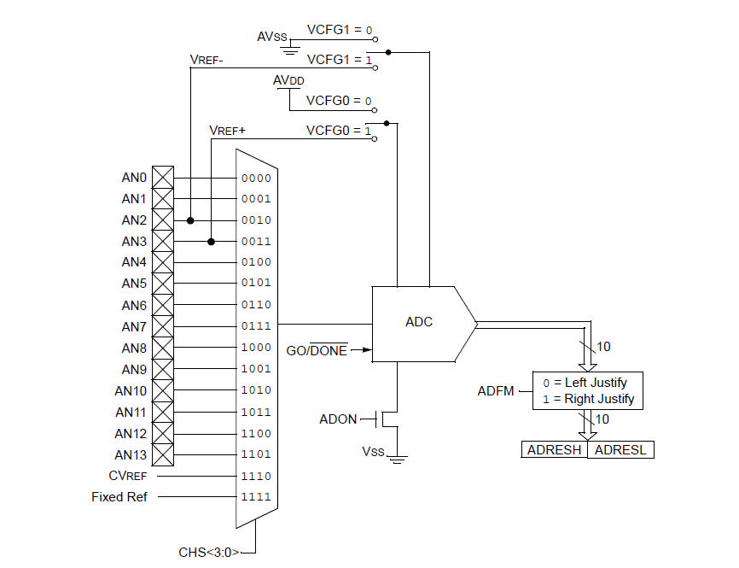

Figure 4. ADC block Diagram (PIC, pg 101)

In register ADCON1 bit 5 and 4 the analog voltage references could be change.

Ein Bild, das Text enthält.

##### ADC sampling procedure

##### ADC Acquisition Time

After the ADC module has been configured as desired, the analog signal of the selected channel must be acquired before the conversion is started.

After the analog input channel is selected (changed), this acquisition must be done before the conversion can be started.

To calculate the minimum acquisition time TACQ, you can use the equation below. This equation assumes that 1/2 LSB error is used (1024 steps for the A/D). The 1/2 LSB error is the maximum error allowed for the A/D to meet its specified resolution.

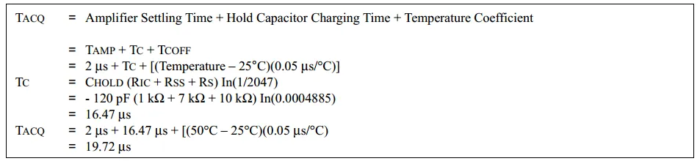

This equation is derived depending on the analog input model circuitry in the diagram below. And you can optimize your system for much lower acquisition time by a little bit more investigation in this model. Alternatively, you can shoot for a safe value instead.

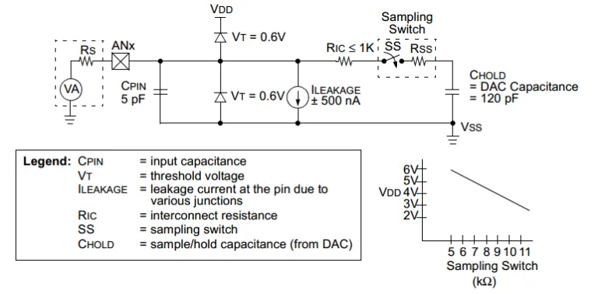

**A/D Conversion Clock Selection**

The A/D conversion time per bit is defined as TAD. The A/D conversion requires a minimum of 12 TAD per 10-bit conversion. The source of the A/D conversion clock is software selected.

For correct A/D conversions, the A/D conversion clock (TAD) must be selected to ensure a minimum TAD time of 1.6 µs (pag 260)

**A/D Sample time**

The acquisition time TACQ is the time that the A/D module’s holding capacitor is connected to the external voltage level.

Then there is the conversion time TC of 10 TAD, which is started when the GO bit is set. The sum of these two times is the sampling time TS. Hence, the sampling frequency FS = 1 / TS.

Ein Bild, das Text enthält.

Results

You can decrease the sample time decreasing the resolution of the ADC.

Baud Rate of 9600

Ein Bild, das Text, Screenshot, Bildschirm enthält.

Baud Rate of 57600

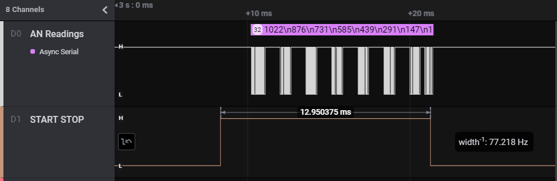

#### UART

##### UART register configuration

##### Sending of Samples

The UART send data packages of 8 bits. The sample values could be from 0 to 1024, so the values are divided into a maximum of 4 ASCI values. At the end of each sample a new line is sent with the value of 10. When all the values from the 8 sensors are sent

### Upload of Code with PICK-IT

## User Interface Computer

### Plotter

### User Interface Structure

## Schematic

|  |  |  |  |
| --- | --- | --- | --- |
|  |  | Reichelt | Mouser |
| MCP6004 | 5 |  |  |
| Interuptor |  |  |  |
| HSC-05 |  |  |  |
| HST-X4 |  |  |  |
| PIC |  |  |  |
| Battery 18650 |  |  |  |
| Capacitor 47p |  |  |  |

### Configuration of the Sensor

### Complete Schematic

Functionality Completar nombre sensor

According to Tekscan Manual, there are 3 ways to implement the Sensor, with an noninverting, inverting opamp configuration and with a resistor divider. The best option for this proyect is the

## Proposed improvements

Despite the fact that prototype from Ibarra (2020), had meaningful readings, there are some deficiencies that could be improved. To start with, the system was unreliable being that the results could not be repeated by every operator. In addition, the resolution from the reading could also be improved being that the steps int the measurement considerably high, as they can be easily seen at a glance. Moreover, the possibility of having 8 sensors could be helpful in further analysis, in comparison with Ibarra’s system which had capability for 6 sensors.

According to Tekscan (2018) manual of electrical implementation, each sensor has a variation between the values of resistance according to the pressure. For this reason, every sensor should be calibrated independently. A potentiometer could be implemented to each sensor to make sure that the sensor is giving values in a proper range of values.

In the last project an Arduino with an ADC with a resolution of 10 bits from 0 to 5v was implemented. According to Tekscan datasheet the range of values that the sensor can give depends on the Equation 1. In this case the ADC is not gut exploited using only x steps of resolution form the ADC. With a PIC microcontroller the ADC works from 0 to 3.3 V. It also has 10 bits resolution (steps). If we decrease the reference voltage, we could have a broader range of values. So, the solution is to implement a voltage divider and voltage follower to input a lower voltage reference.

The resolution of the ADC is calculated as in Equation ( 6), where $V_{{ref}^{+}}$ is the maximum sample voltage from ADC and $V_{{ref}^{-}}$ the minimum. From the same equation n is the number of bits of the ADC. In Arduino Micro the default voltage configuration from $V_{{ref}^{+}}$ and $V_{{ref}^{-}}$ is the from 5v and ground. The number of bits is of 10. Substituting the values in the equation we get a value of

|  |  |
| --- | --- |
| $$Resolution=\frac{V_{{ref}^{+}}-V_{{ref}^{-}}}{2^{n}}$$ | ( 6) |
|  |  |
| $$Resolution=\frac{5-0}{2^{10}}=488\frac{mV}{devision}$$ | ( 7) |
|  |  |

The Opamps proposed for the design are the MPC6006 because have rail to rail property and are recommended in the electrical implementation manual (Tekscan, 2018). The rail-to-rail property means that the difference between the maximum output voltage from the opamp and the voltage source will be very similar, in comparison with other opamps that have a voltage drop about 700 mV. Any other Opamp could be used if it has rail to rail property.

The connections from the sensors to the circuit should be connected more securely fastened, because the last prototype had pin header to connect the sensors. HST were proposed to connect and disconnect sensors if needed, and enough to withstand the movement of the gait.

To reach a final product design a PCB with SMD (superficial mounted device) components could give a better presentation and a decrease in the overall size of the device.

With the problems identified above, the particular objectives and Design requirements for the project are the following.

There are some things which are still not considered for an optimal result. These conflicts could be developed on future projects.

One problem is that the arrangement of the sensors when installing the device on the user for test, is not very comfortable, being that the sensors are flexible, but not so much, they tend to bend, in that is harmful in the long term for the sensors. The only solution so far is to place the device in a fanny pack or to design a fastener that could be adjusted around the leg.

It hasn’t been researched why these were the sensors that were implemented, probably there are some other better than these ones. That has not been questioned.

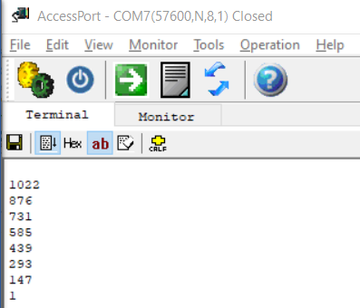

Next Steps:

Chek calibration guidelines from Flexiforce Sensors RevL

References

Tekscan. (2018). FlexiForce™ Sensor Durability, Drift, Recovery, and its Impact on Your Design. March 12, 2021, from Tekscan Website: [www.tekscan.com/FlexiForce-Integration-Guides](http://www.tekscan.com/FlexiForce-Integration-Guides)

Tekscan. (2018). Best Practices in

Electrical Integration of the FlexiForce™ Sensor. March 12, 2021, from Tekscan Website: [www.tekscan.com/FlexiForce-Integration-Guides](http://www.tekscan.com/FlexiForce-Integration-Guides)

Tekscan. (2018). FlexiForce™

Integration Guide. March 12, 2021, from Tekscan Website: [www.tekscan.com/FlexiForce-Integration-Guides](http://www.tekscan.com/FlexiForce-Integration-Guides)

Pitkin, M. R. (2009). *Biomechanics of lower limb prosthetics*. Springer.

Ibarra Aguila, S., Sánchez, G. J., Sauvain, E. E., Alemon, B., Fuentes-Aguilar, R. Q., & Huegel, J. C. (2020). Interface Pressure System to Compare the Functional Performance of Prosthetic Sockets during the Gait in People with Trans-Tibial Amputation. *Sensors*, *20*(24), 7043.

Cargador bateria <https://www.youtube.com/watch?v=clg4DZ1uvVA>

<https://www.youtube.com/watch?v=VVmOtM60VWw> Enclosure